Name:
Date:
17.06 Elevens Lab Worksheet
Directions: Make note of your responses to the following questions as you work through the activities and exercise in the lesson.

Activity 1 Exercise Results
- From step a, paste your Card class constructor below.

public Card(String cardRank, String cardSuit, int cardPointValue)
{
rank = cardRank;
suit = cardSuit;
pointValue = cardPointValue;
}
From step c, paste your matches method below.

public boolean matches(Card otherCard)
{
if(rank.compareTo(otherCard.rank()) == 0 && suit.compareTo(otherCard.suit()) == 0 && pointValue == otherCard.pointValue())
{
return true;
}
else
{
return false;
}
}
- Paste the results of running the CardTester.java class below.
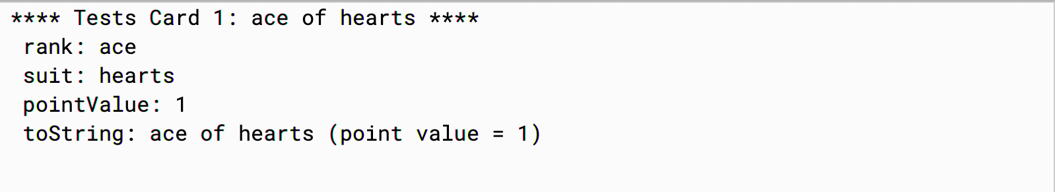

Activity 2 Exercise Results
- From step a, paste your Deck class constructor below.
public Deck(String[] ranks, String[] suits, int[] values)
{
for(int i = 0; i < suits.length; i++)
{
for(int j = 0; j < ranks.length; j++)
{
cards.add(new Card(ranks[j],suits[i],values[j]));
size++;
}
}
shuffle();
}
From step b, paste your isEmpty method below.
public boolean isEmpty()
{
if(size == 0)
{
return true;
}
else
{
return false;
}
}

From step d, paste your deal method below.
public Card deal()
{
if (size == 0)
{
return null;
}
else
{
size--;
return cards.get(size);
}
}
Paste the results of running the DeckTester.java class below.
Had an error.

Activity 2 Questions:

- Explain in your own words the relationship between a deck and a card.
A deck is a collection of cards.

- Consider the deck initialized with the statements below. How many cards does the deck contain? __6__

String[] ranks = {"jack", "queen", "king"};
String[] suits = {"blue", "red"}; int[] pointValues = {11, 12, 13};
Deck d = new Deck(ranks, suits, pointValues);

- Many card games are played with a deck of 52 cards. It is common for ranks to run from ace (highest) down to 2 (lowest). Suits are spades, hearts, diamonds, and clubs. A face card has point value 10; an ace has point value 11; point values for 2, …, 10 are 2, …, 10, respectively. Write the statements to declare and initialize the contents of the ranks, suits, and pointValues arrays so that the following statement initializes a deck as described.
Deck d = new Deck(ranks, suits, pointValues);
String [ ] ranks = {“2”, “3”, “4”, “5”, “6”, “7”, “8”, “9”, “10”, “jack”, “queen”, “king”, “ace”};
String [ ] suits = {“spades”, “hearts”, “diamonds”, “clubs”};
int [ ] pointValues = {2, 3, 4, 5, 6, 7, 8, 9, 10, 10, 10, 10, 11};

- Does the order of elements of the ranks, suits, and pointValues arrays matter?

Elements of suits may appear in any order. Elements of ranks may be reordered, as ranks are not ordered in Elevens, as long as the pointValues elements are reordered in the same way. In card games where rank order is important, the sequence of elements in the ranks variable should be in order.

